Task:

What’s given

A personal AWS account was created, and billing alerts were set up.

What to do

Sub-task 1 – Create 3 User Groups

Let’s imagine that we have created an AWS Account that will use all members of our AWS program(Coordinator, Mentees, Mentors(Experts)). For all these users it will be better to create different groups with different permissions because for example Coordinator has more permissions than Mentee. Please create 3 user groups:

CoordinatorsGroup

MentorsGroup

MenteesGroup

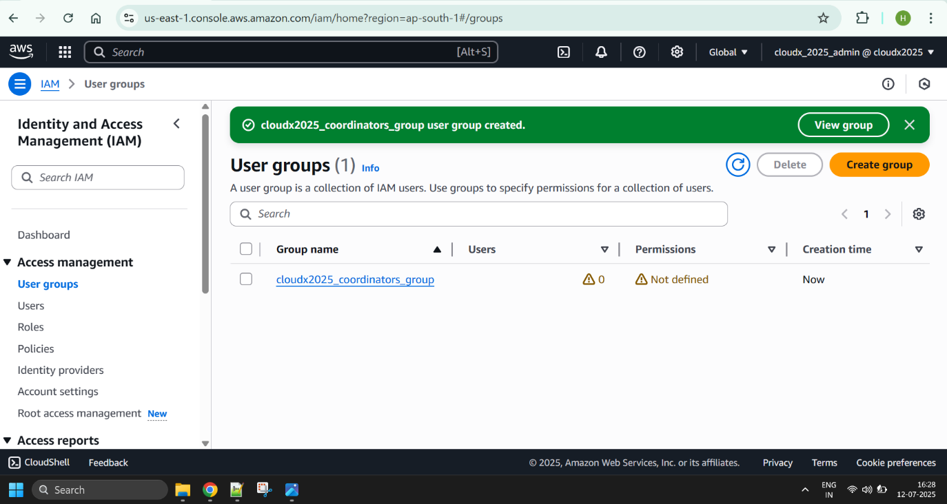

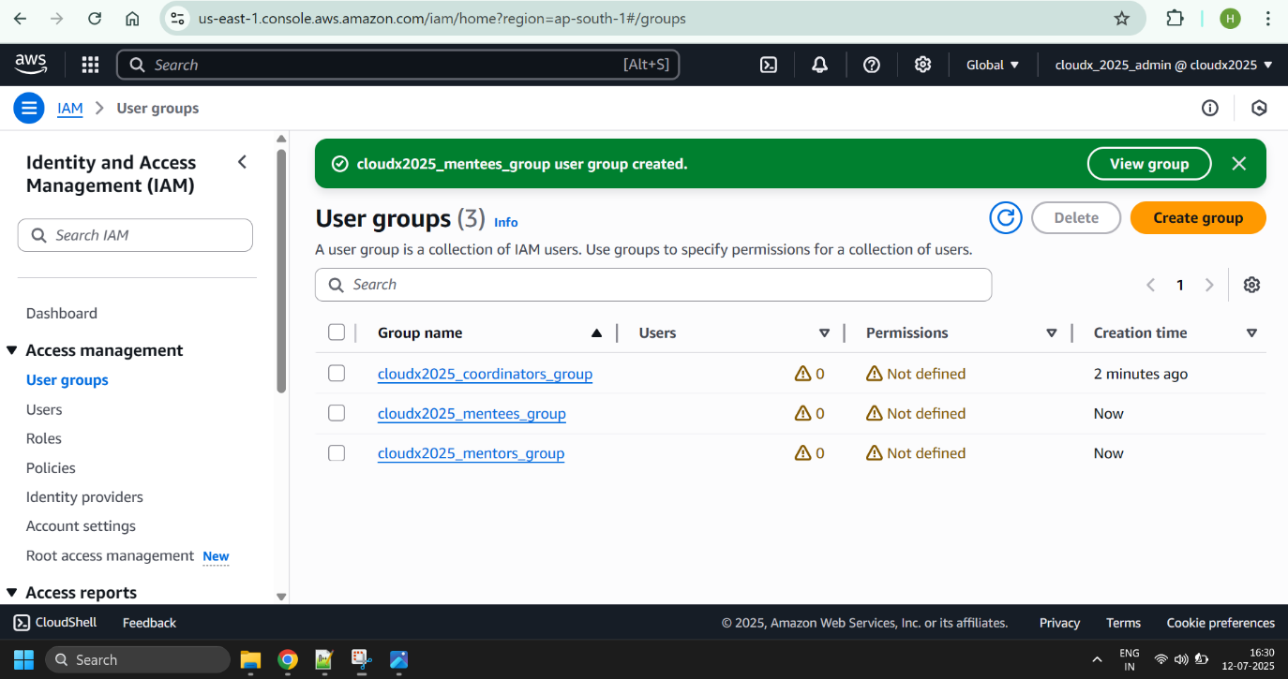

Sub-task 2 – Create policies and roles

Create a policy named FullAccessPolicyEC2.

Configure the FullAccessPolicyEC2 to allow any actions on the EC2 resources.

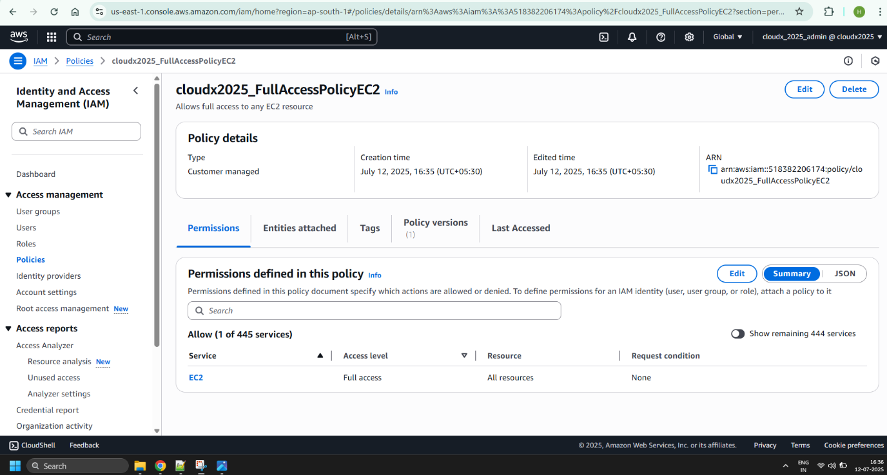

Similarly, create policies for S3:

FullAccessPolicyS3 – everything’s allowed.

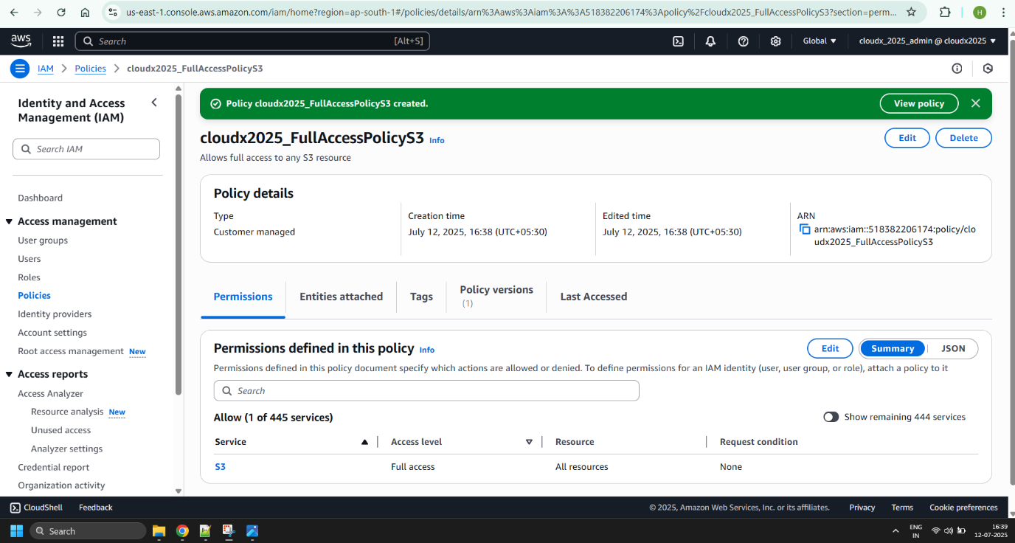

ReadAccessPolicyS3 – only get and list actions.

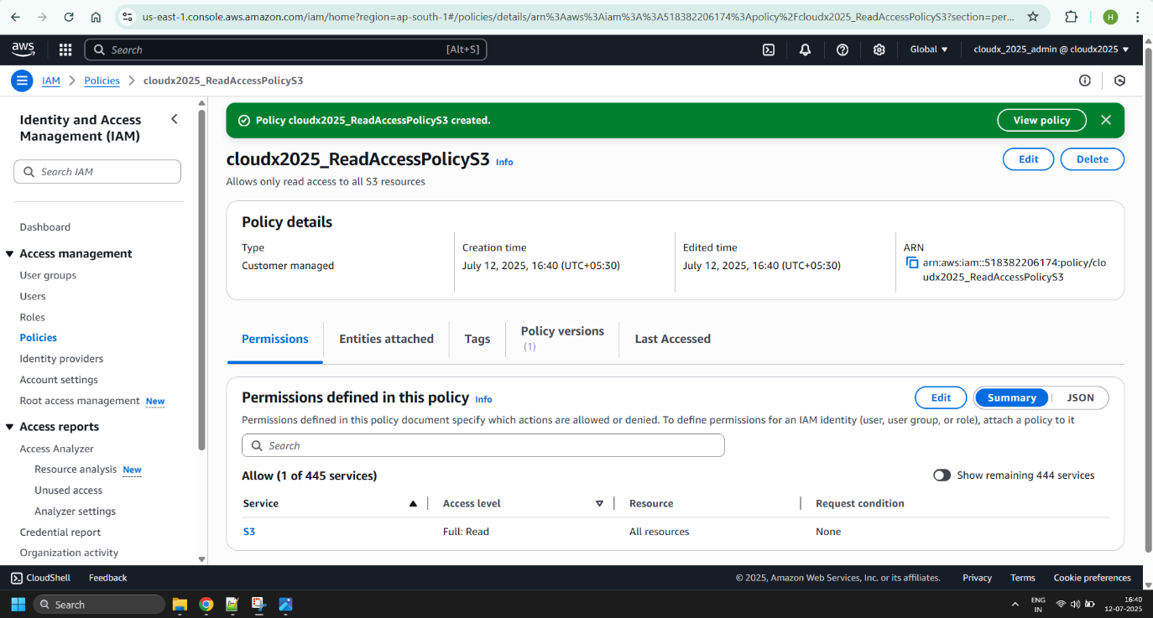

Create one role of EC2 Type (Trusted Entity) per each policy configured so far (note – these roles won’t be used right now, but might be reused in the upcoming EC2 module):

FullAccessRoleEC2

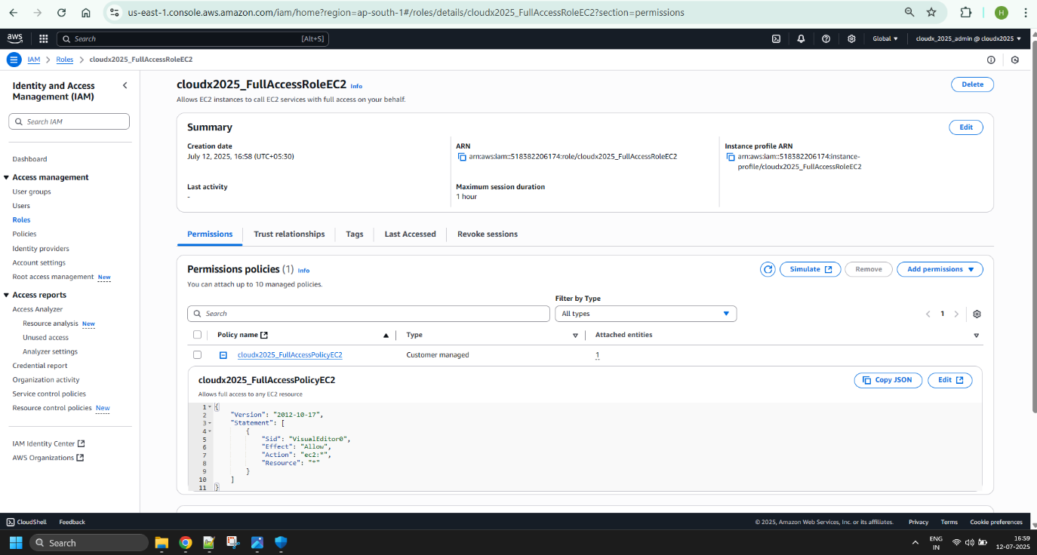

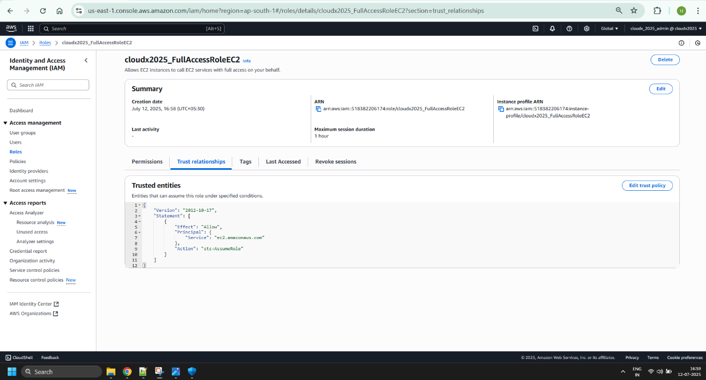

FullAccessRoleS3

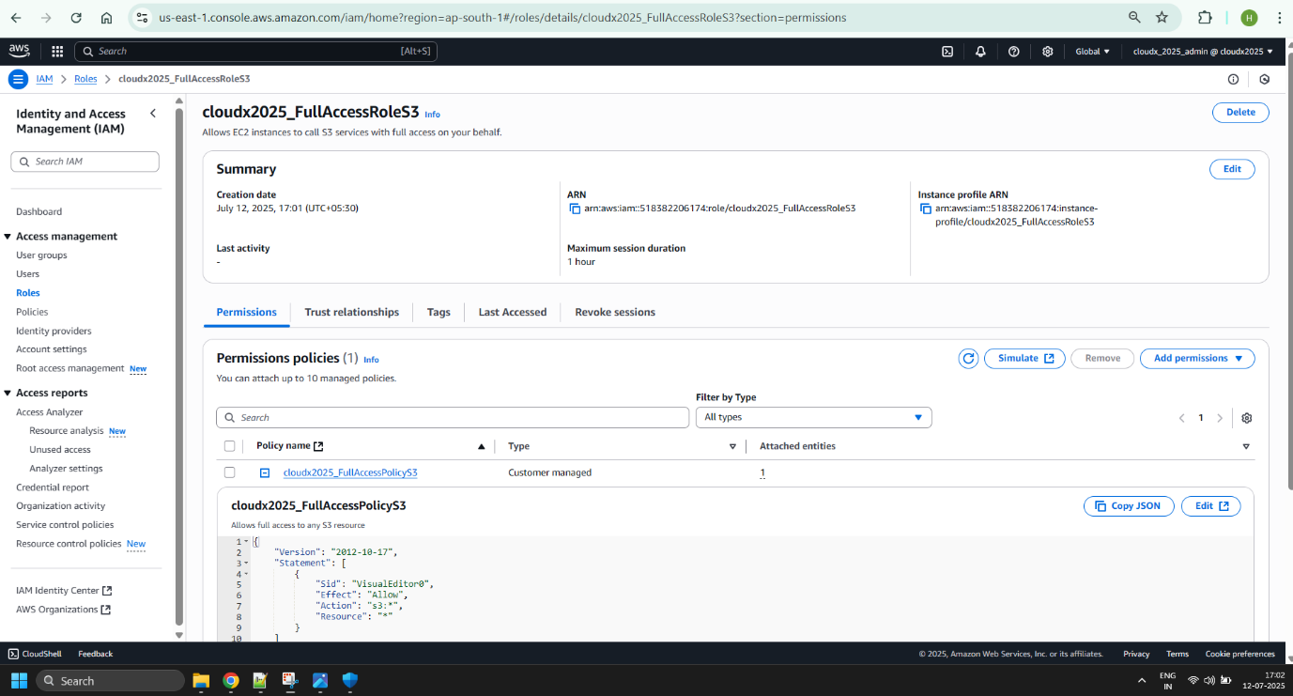

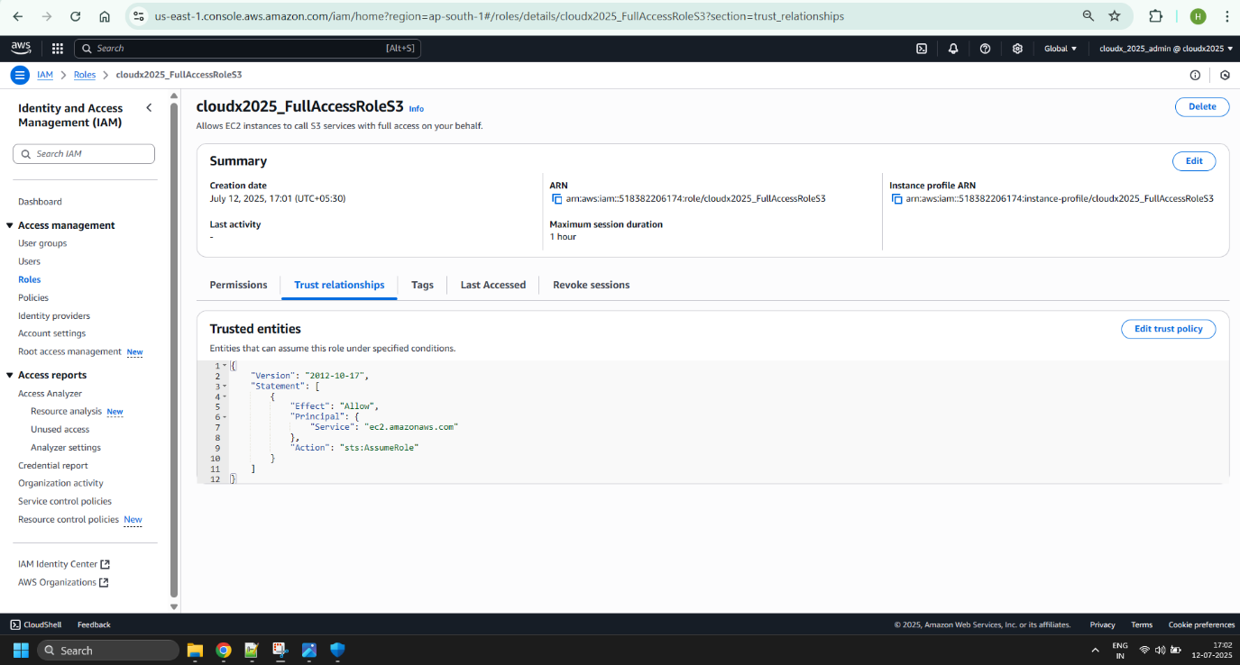

ReadAccessRoleS3

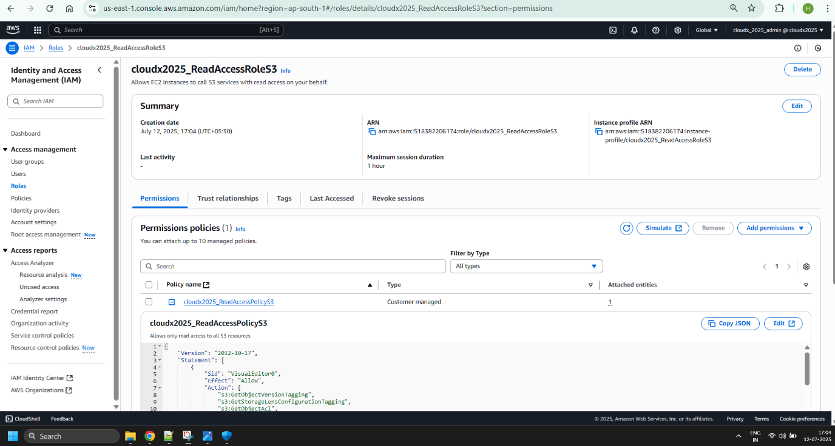

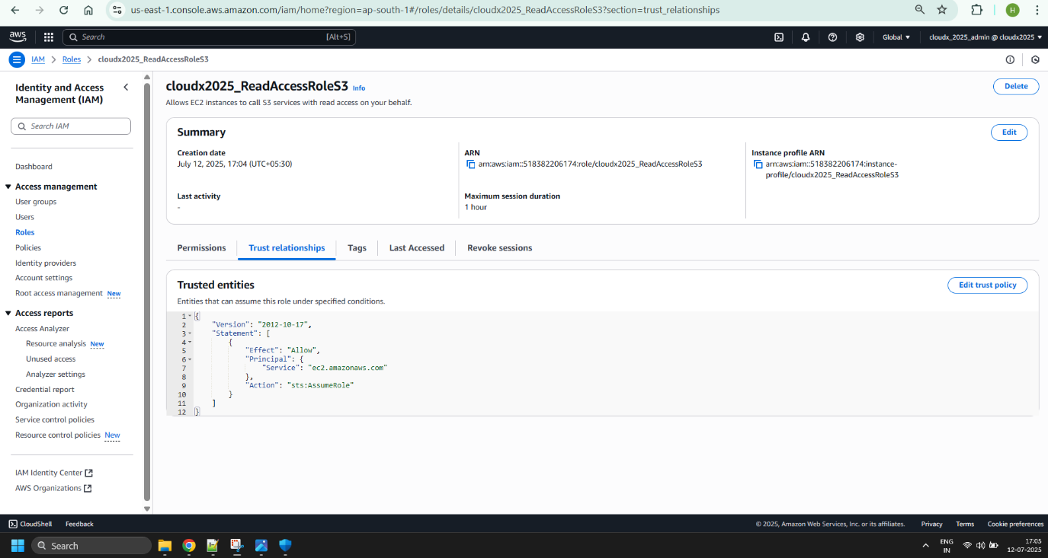

Create one group per each policy configured so far:

FullAccessGroupEC2

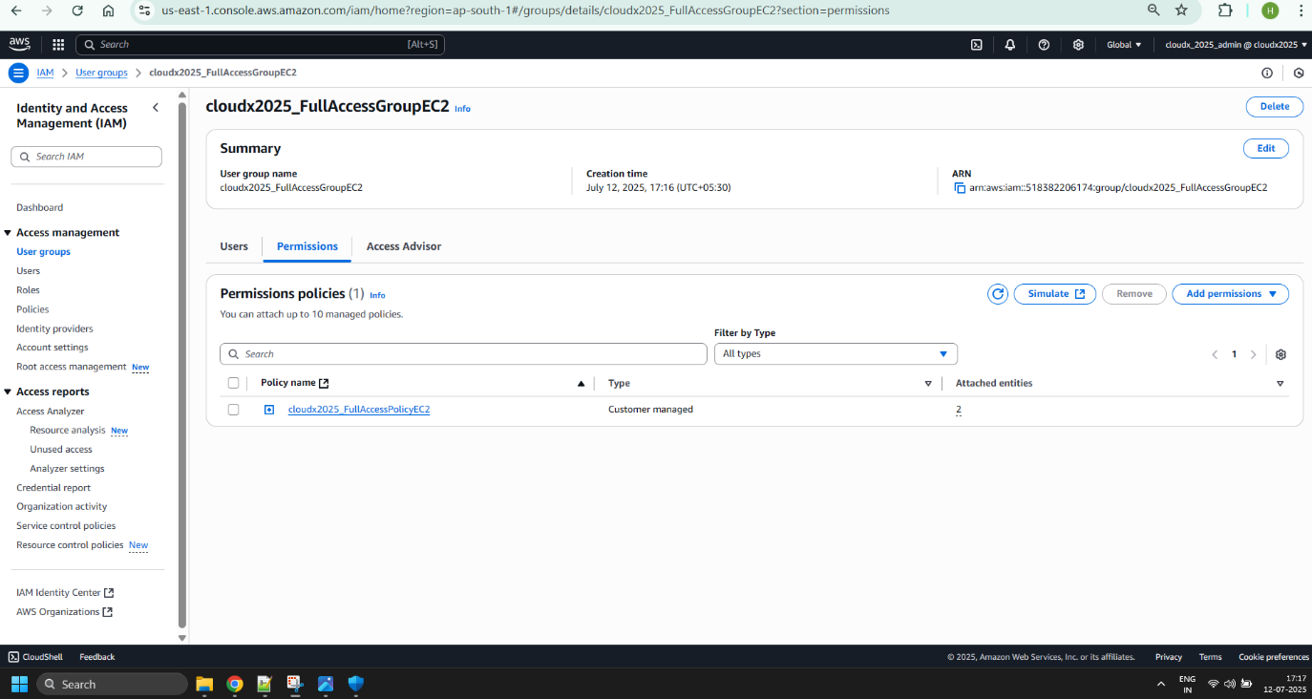

FullAccessGroupS3

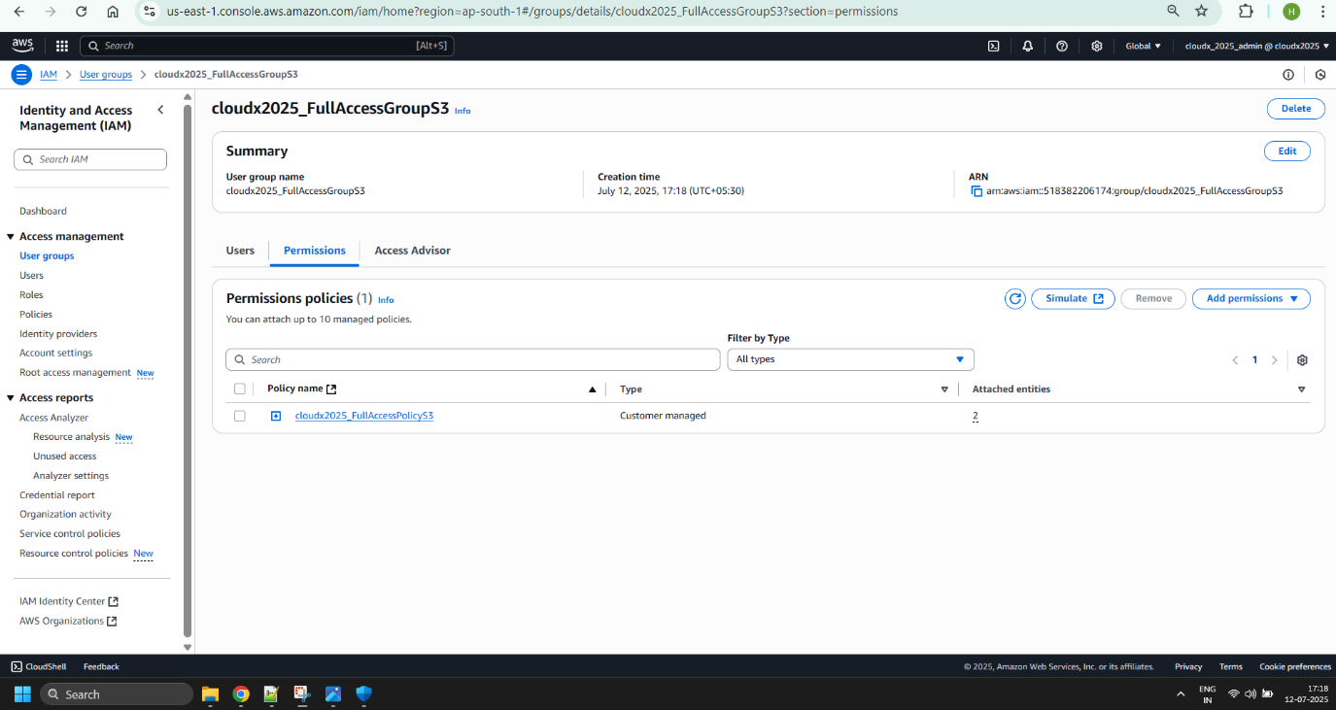

ReadAccessGroupS3

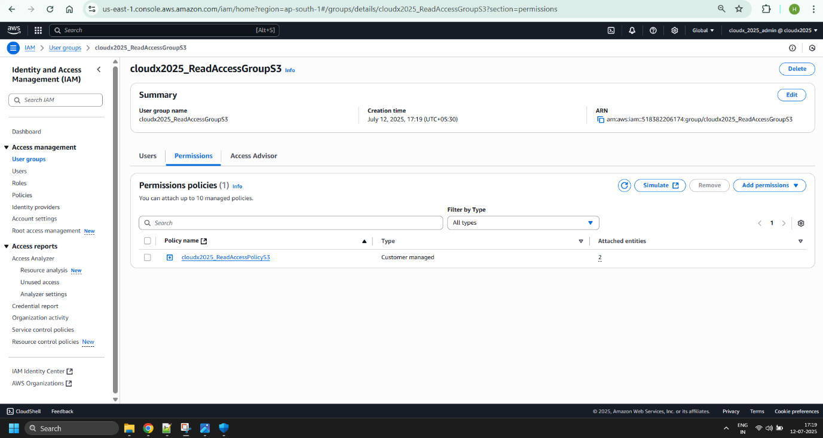

Create 1 user from the 1st group, 1 user from the 2nd group, and 1 user from the 3rd group.

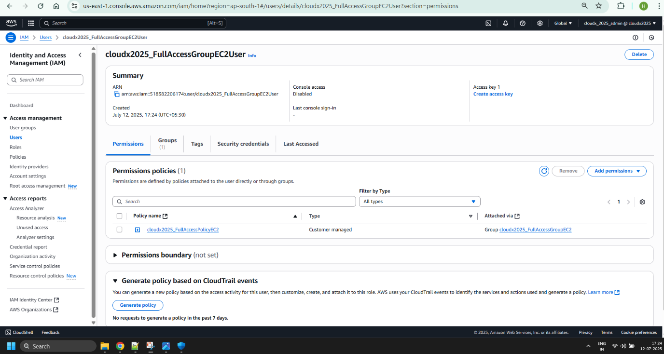

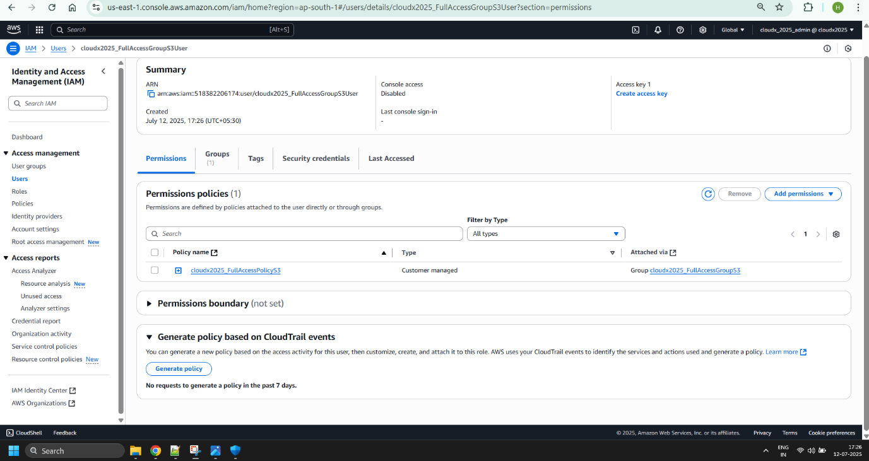

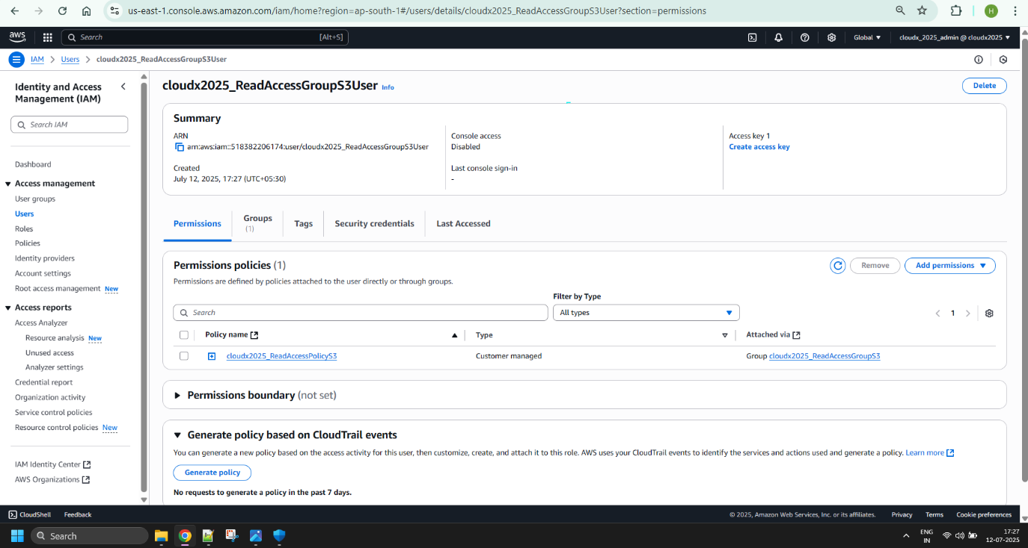

Add inline policy for user1 for write access to S3. The inline policy is a policy created for a single IAM identity (a user, group, or role). Inline policies maintain a strict one-to-one relationship between a policy and an identity. For more information please see <https://docs.aws.amazon.com/IAM/latest/UserGuide/access_policies_managed-vs-inline.html>

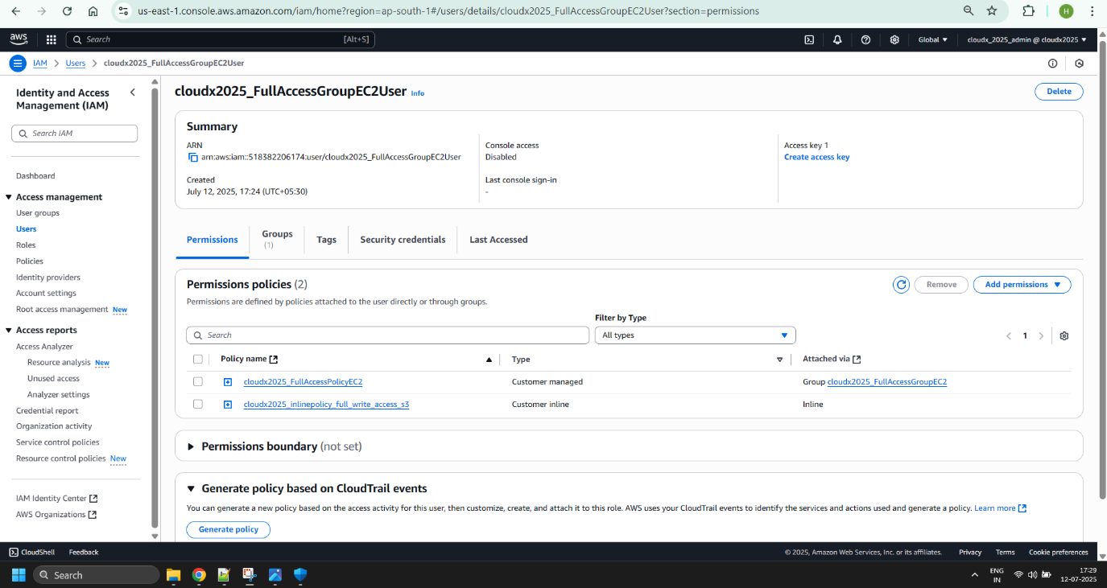

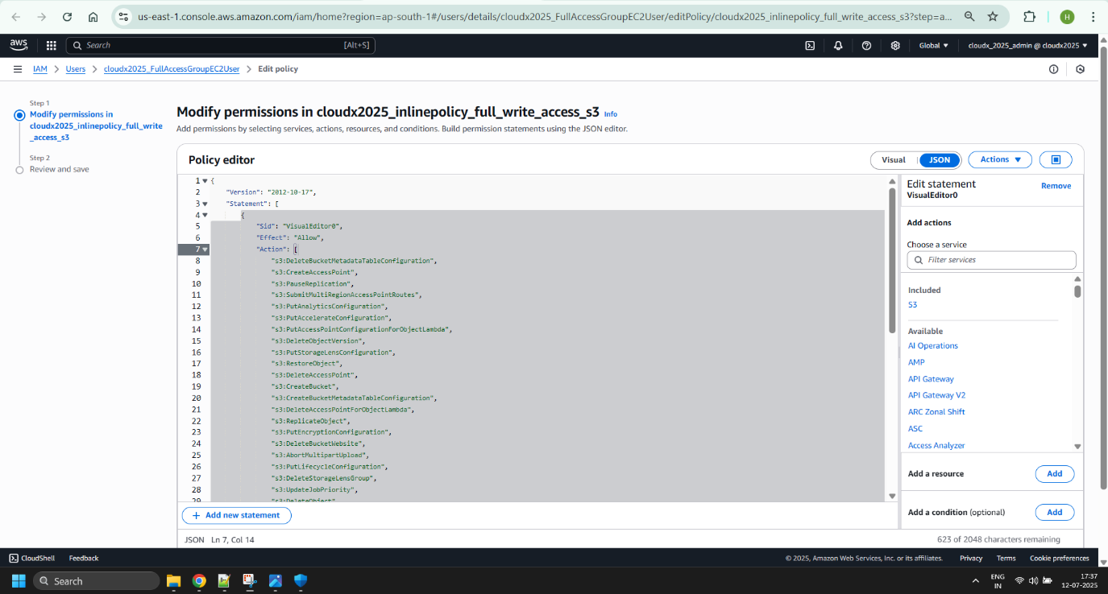

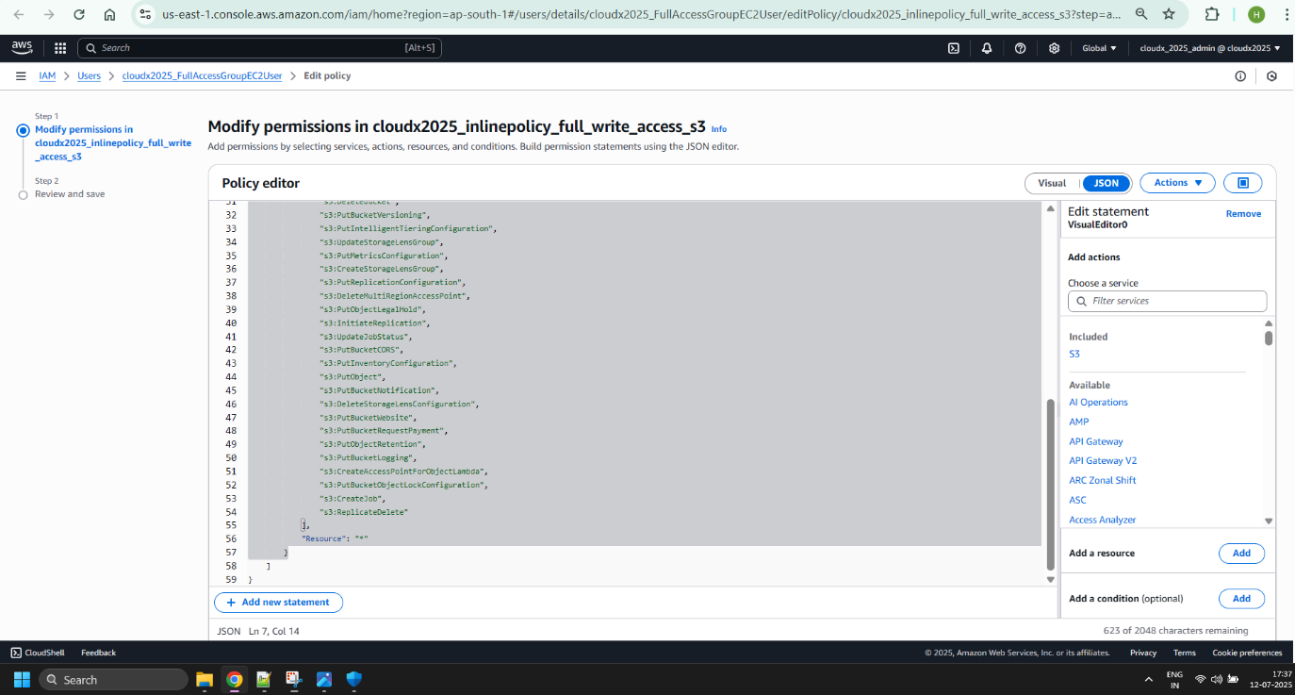

Install the latest version of the AWS CLI. Please follow this guide https://docs.aws.amazon.com/cli/latest/userguide/getting-started-install.html.

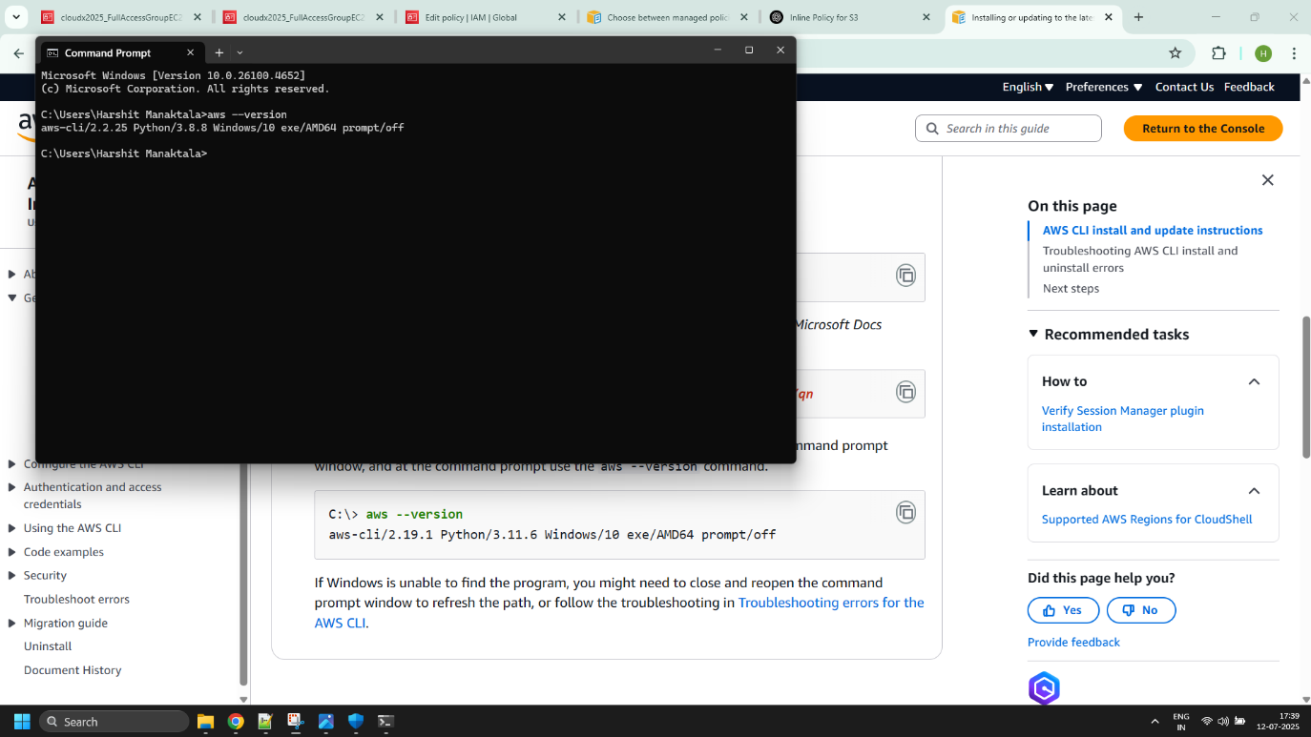

Configure named profiles for each user from the step #6 to be used with AWS CLI in the subsequent modules. For more info please see https://docs.aws.amazon.com/cli/latest/userguide/cli-configure-profiles.html

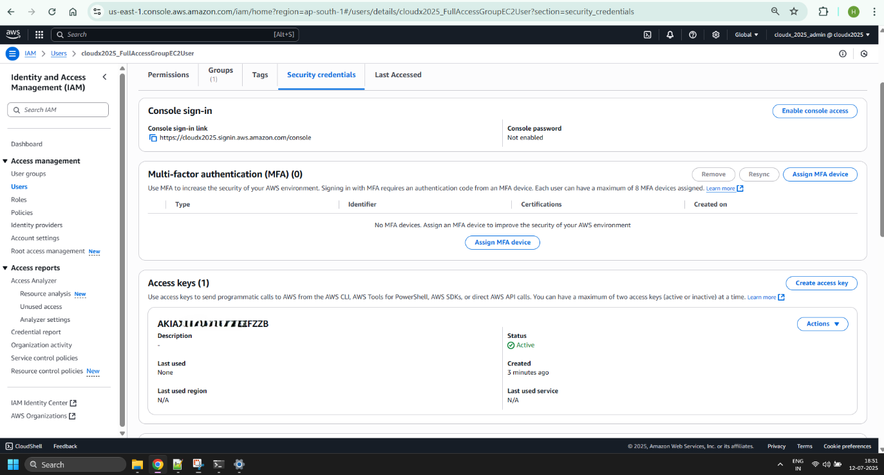

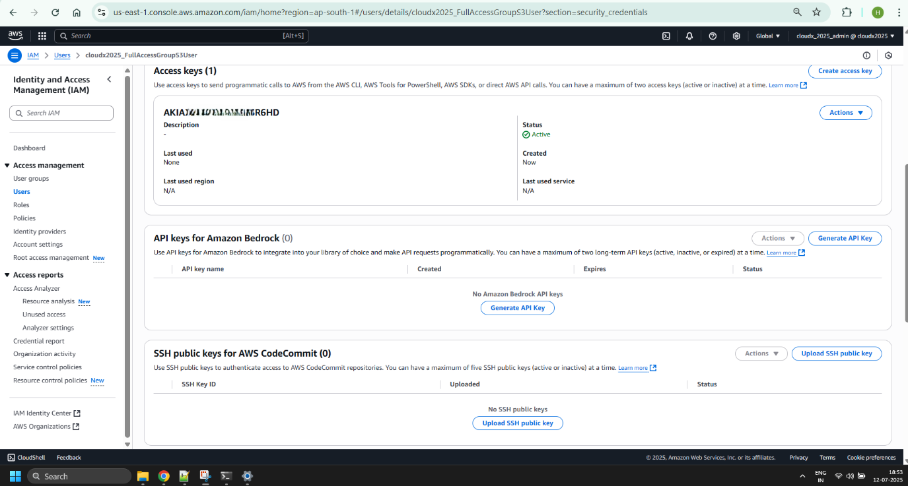

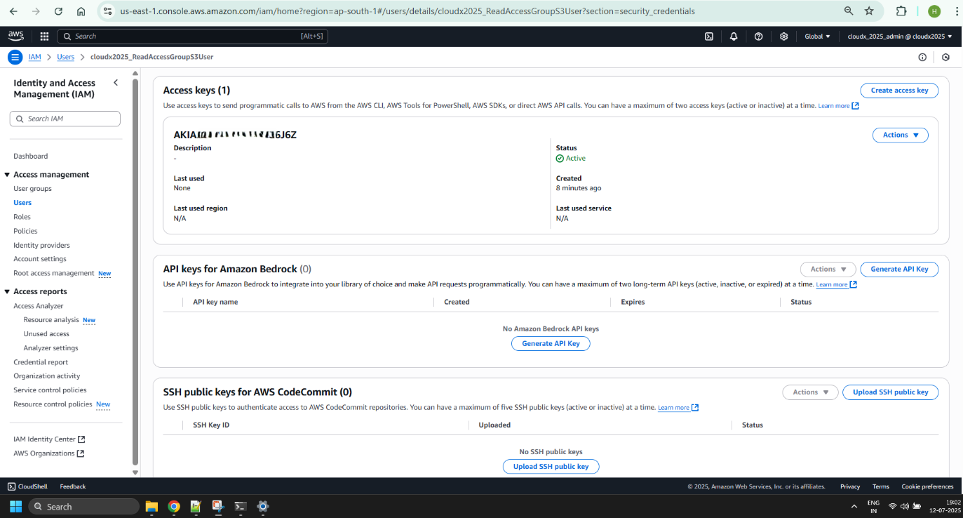

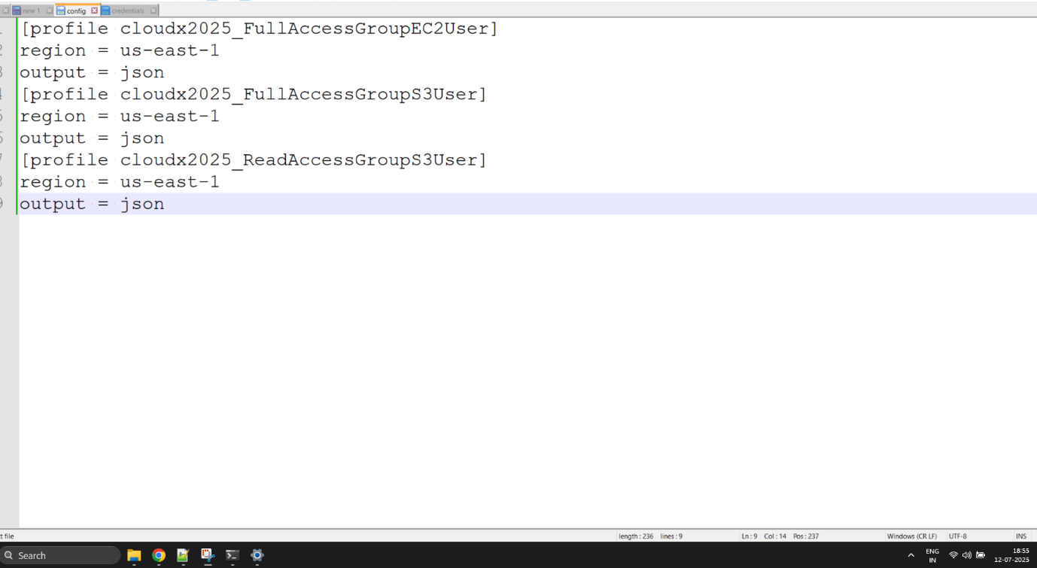

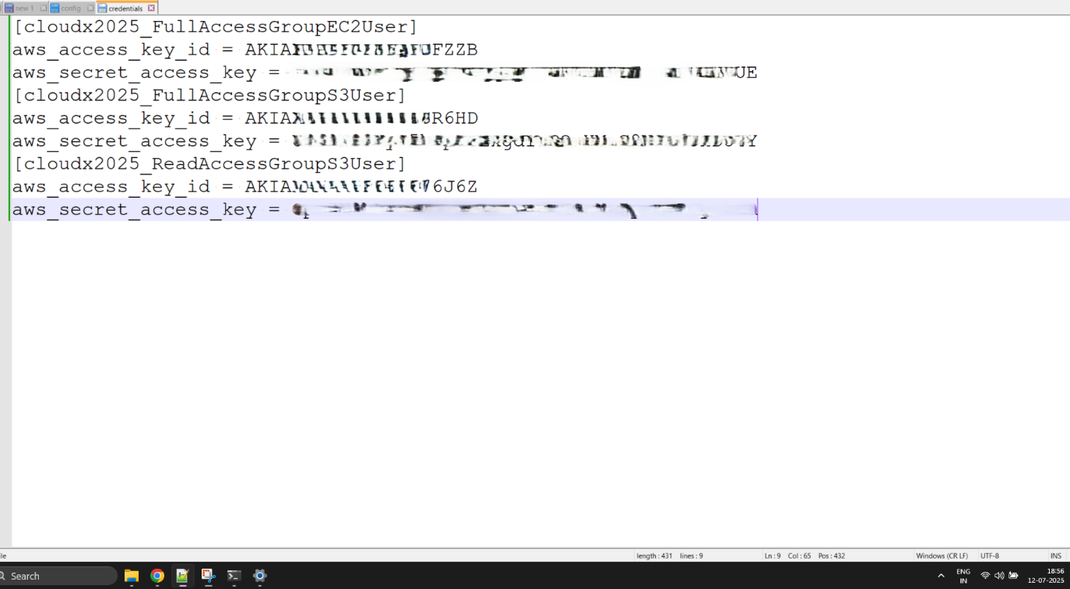

What should I remember?

Once you create AWS Account -> Setup Multi-factor Authentication

Do NOT share your account

Do NOT commit your account Credentials into the Git

Terminate/Remove all created resources/services once you finish Module

Please Do not forget to delete NAT Gateway if you used it.

Do NOT keep instance running if you don’t use it

Carefully keep track of billing and working instances so you don't exceed limits